Task 1
Kiara A Ganger
007775841
Western Governors University
D207 | Exploratory Data Analysis

Author Note
Data File Being Used: churn_clean.csv
Table of Contents
A. Describing a Real-World Organizational Situation or Issue in the Chosen Data Dictionary 3
B. Description of The Data Analysis 3
C. Univariate Statistics of Two Continuous and Two Categorical Variables: 4
D. Bivariate Statistics of Two Continuous and Two Categorical Variables: 5
E. Summarize the implications of your data analysis: 6
F. Panopto Video: 6
G. Third-Party Code: 6
H. References” 6

Describing a Real-World Organizational Situation or Issue in the Chosen Data Dictionary
- Question:
Is there an association between customers' annual income and their likelihood of churning from the service?
- Explanation:
Stakeholders can benefit from this analysis because understanding how income influences churn will allow them to tailor retention strategies. For example, if the data shows that customers with a lower income have a higher tendency to churn, then the company can focus on offering more deals or affordable plans to retain them. Understanding the needs and preferences of different income groups will guide product development, customer service interactions and how they market their services in different areas.
- Data Used:
The variables that will be useful in answering this question will be:
- Income -Annual income of customers, which is one of the independent variables under investigation.
- Churn - This variable indicates whether each customer churned or not. It serves as the dependent variable for the analysis.

Description of The Data Analysis
- Technique Used: Chi-Square Test:
1. # Load necessary libraries
2. library(ggplot2)
3. library(dplyr)
4.
5. # Load the dataset
6. churn <- read.csv("C:/Users/kiara/OneDrive/WGU MSDA/D207/churn_clean.csv")
7. View(churn)
8.
9. # Perform Chi-square test
10. chi_square_result <- chisq.test(churn$Income, churn$Churn)
11.
12. # View the test result
13. print(chi_square_result)
14.
15. # Print out which hypothesis to accept
16. if (chi_square_result$p.value < 0.05) {
17. print("Reject the null hypothesis: There is a significant association between income and churn status.")
18. } else {
19. print("Fail to reject the null hypothesis: There is no significant association between income and churn status.")
20. }
21.
- Output of code:
- Pearson's Chi-squared test
- data: churn$Income and churn$Churn
- X-squared = 9994.9, df = 9992, p-value = 0.49
- "Fail to reject the null hypothesis: There is no significant association between income and churn status."
- Justification:
The chi-square test is perfect for examining the relationship between two categorical variables, like income levels and churn status. It helps us see if there's a significant association between these variables by comparing observed and expected frequencies. Another benefit of the chi-square test is that it doesn't assume any specific distribution, it's flexible and works well even if the data isn't normally distributed. It's ideal for counting data, which is exactly what we have with customer income groups and churn status. The results were easy to understand (McHugh M. L. 2013).

Univariate Statistics of Two Continuous and Two Categorical Variables:
Continuous Variables:
MonthlyCharge: The amount charged to the customer monthly.
MonthlyCharge is closer to a Bell type shape it has a normal distribution.
Bandwidth_GB_Year: The average amount of data used, in GB, in a year by the customer.
Bandwidth_GB_Year has two non-symmetrical hills giving a non-symmetric bimodal distribution.
Categorical Variables:
Churn: Whether the customer discontinued service within the last month (Yes or No).
Churn is skewed right distribution.
InternetService: Customer's internet service provider (DSL, fiber optic, None).
InternetService is closer to a Bell type shape it has a normal distribution.
- Visualization:
Represented using R
Code used and visuals: I reused code from my D206 task.
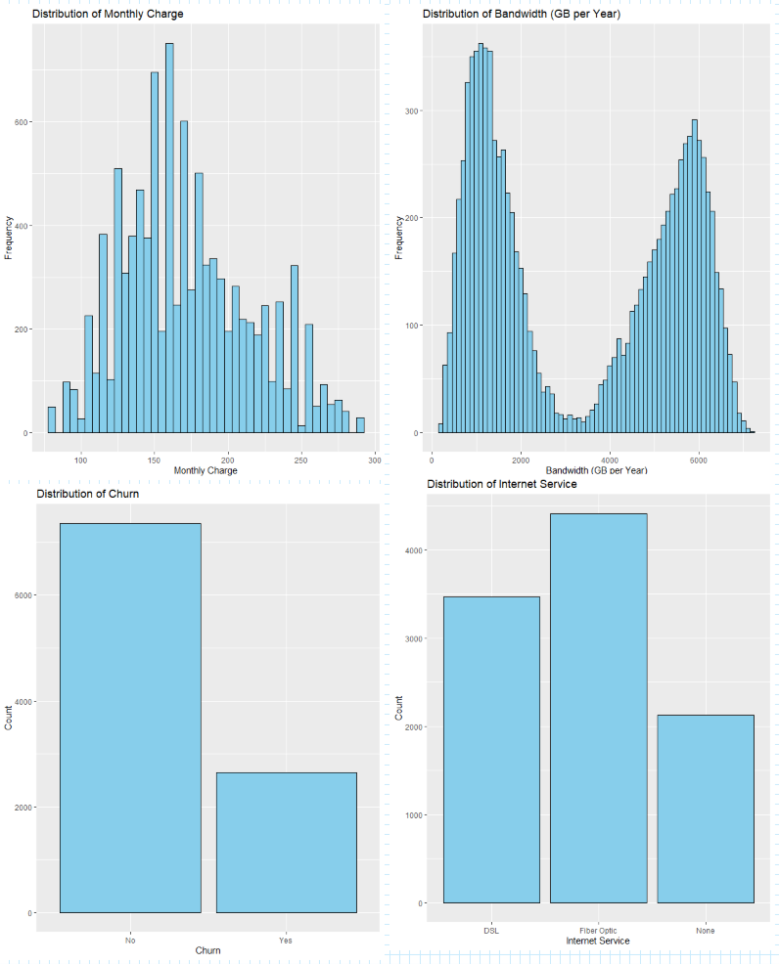
1. # Load necessary libraries
2. library(ggplot2)
3. library(dplyr)
4.
5. # Load the dataset
6. churn <- read.csv("C:/Users/kiara/OneDrive/WGU MSDA/D207/churn_clean.csv")
7.
8. # Plot histogram for MonthlyCharge
9. ggplot(churn, aes(x = MonthlyCharge)) +
10. geom_histogram(binwidth = 5, fill = "skyblue", color = "black") +
11. labs(title = "Distribution of Monthly Charge", x = "Monthly Charge", y = "Frequency")
12.
13. # Plot histogram for Bandwidth_GB_Year
14. ggplot(churn, aes(x = Bandwidth_GB_Year)) +
15. geom_histogram(binwidth = 100, fill = "skyblue", color = "black") +
16. labs(title = "Distribution of Bandwidth (GB per Year)", x = "Bandwidth (GB per Year)", y = "Frequency")
17.
18. # Plot bar plot for Churn
19. ggplot(churn, aes(x = Churn)) +
20. geom_bar(fill = "skyblue", color = "black") +
21. labs(title = "Distribution of Churn", x = "Churn", y = "Count")
22.
23. # Plot bar plot for InternetService
24. ggplot(churn, aes(x = InternetService)) +
25. geom_bar(fill = "skyblue", color = "black") +
26. labs(title = "Distribution of Internet Service", x = "Internet Service", y = "Count")

Bivariate Statistics of Two Continuous and Two Categorical Variables:
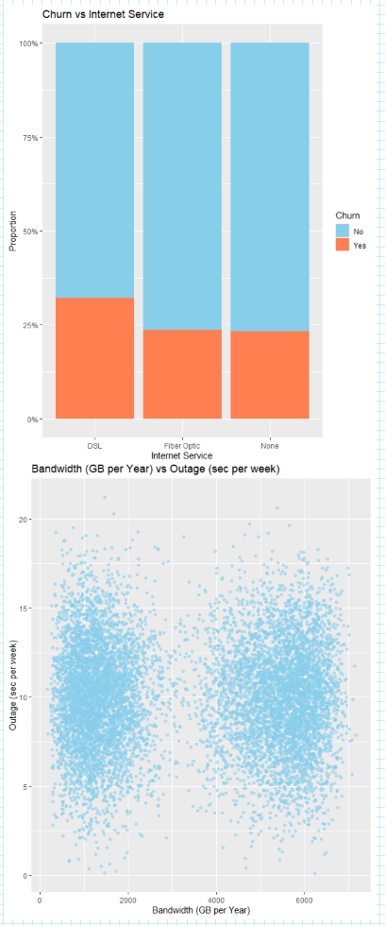
Continuous Variables:
Bandwidth_per_year vs Outage_sec_perweek
Is displayed on a scatterplot.
Categorical Variables:
Churn vs InternetService
Is displayed on a bar chart.
- Visualization:
Represented using R
Code used and visuals: (Johnson, 2024)
1. # Scatter plot for Bandwidth_GB_Year vs Outage_sec_perweek
2. ggplot(churn_data, aes(x = Bandwidth_GB_Year, y = Outage_sec_perweek)) +
3. geom_point(alpha = 0.5, color = "skyblue") +
4. labs(title = "Bandwidth (GB per Year) vs Outage (sec per week)", x = "Bandwidth (GB per Year)", y = "Outage (sec per week)")
5.
6. # Bar plot for Churn vs InternetService
7. ggplot(churn_data, aes(x = InternetService, fill = Churn)) +
8. geom_bar(position = "fill") +
9. labs(title = "Churn vs Internet Service", x = "Internet Service", y = "Proportion") +
10. scale_y_continuous(labels = scales::percent) +
11. scale_fill_manual(values = c("skyblue", "coral"), name = "Churn")
12.
13. # Perform chi-square test for Churn vs InternetService
14. chisq_result <- chisq.test(table(churn_data$Churn, churn_data$InternetService))
15. print(chisq_result)

Summarize the implications of your data analysis:
- Results of The Hypothesis Test
The hypothesis test for this analysis was to see if there was any association between Income and the chances of the customer churning. After running a chi-square test the results indicated a chi value of 9994.9 with 9992 degrees of freedom and a p-value of 0.49. Based on these results, I concluded that I failed to reject the null hypothesis. Since the p-value was greater than 0.05 it made it clear that theirs is no significant link between income and churn.
In Part D, the results of the Bivariate Statistics showed that there is an association between Churn vs Internet Service (p-value less than 0.05) but not between Bandwidth_GB_Year vs Outage_sec_perweek(p-value greater than 0.05).
- Limitations of Your Data Analysis
Some of the limitations of the analysis can be broken down into parts. 1st the test ran relies heavily on the completeness of the dataset. If there are values that are missing whether it be from over cleaning the data, it can lead to biases in the results. 2nd I only analyzed the variables I selected, not any other relevant information in the dataset that may influence churn and income. Lastly the analysis is based on this one report. Not any changes that a customer might have in their behavior over time.
- Recommend a course of action based on your results.
Given that there was no significant association between Income and Churn the company should have based their efforts on the quality of the goods and their customer satisfaction. For example, don’t waste money on ads that target lower income customers with sales and promos by instead on the type of internet they offer. Since there was a significant association between Churn and Internet Service.

Panopto Video:
Link: https://wgu.hosted.panopto.com/Panopto/Pages/Viewer.aspx?id=04418beb-e054-4434-81e9-b1760103ba28

Third-Party Code:
Johnson, D. (2024, February 24). GURU99. Retrieved from Scatter Plot in R using ggplot2 (with Example): https://www.guru99.com/r-scatter-plot-ggplot2.html

References
McHugh M. L. (2013). The chi-square test of independence. Biochemia medica, 23(2), 143–149. https://doi.org/10.11613/bm.2013.018

